Chris Sadler returned in 2010 to the village of Keerungudi in Tamilnadu where she had lived for nearly 6 years in the 1970s. Asked to write about the changes she saw, for the magazine Gandhi Talisman she has written an account in three parts, Arriving, Staying, and Returning to Keerungudi.

Part 1 Arriving in Keerungudi

In 1969, the Centenary Year of Gandhiji’s birth, I journeyed overland to India with some friends. We had met at evening meetings held at the London School of Nonviolence. Although I remember being deeply moved by Gandhiji’s life at the age of 12, I was re-inspired by his holistic, interdependent vision of freedom – freedom for all, (for the rich as well as the poor, for the oppressor as well as the oppressed), and freedom in all aspects and levels of our being. His rigorous insistence on the unity of means and ends even in small details impressed me too. After Partition, Independence and the assassination of Gandhi, his ideas were developed further in Vinoba’s vision of resource sharing through Bhoodan, and power sharing and community building through Gramdan. It all seemed far more relevant to justice, to peace, and to life, than the studies I had been doing at the University.

We crossed the border into India on the eve of Diwali and journeyed on through the night. My abiding memory is of sacred beauty and welcoming presence. A myriad of deepas in doorways and on rooftops flickered across the dark and silent landscape. The gentle lights seemed to mirror both the simple goodness of human beings and the boundless starry sky.

We stopped for a brief breakfast in Delhi at the Gandhi Peace Foundation. I was amazed at the sparrows flitting in and out of the house, lizards on the walls – another glimpse of the Indian fluidity between home and nature. Then we headed to Bodh Gaya where already thousands of Sarvodaya workers had gathered with Vinobaji.

It was there I first met Jagannathanji. I shared my desire to know how the ideals of Gramdan and Sarvodaya were being lived out in reality. My nine friends were returning to London, while I thought of staying on for a time. Perhaps I even mentioned the hope to find somewhere where I could meaningfully stay a bit longer, perhaps a year.

With compassion and passion he told me of the massacre at Kizhavenmani, a Harijan or Dalit village, where 44 people, mostly women and children, had been burned alive in 1967, after their men-folk had demanded another half portion of rice as wages. He told me a bit about the condition of the landless poor in that part of Thanjavur District. And he said simply, but compellingly, “Do come. Come and see what we are trying to do.”

And so about six months later I arrived at the Gandhi Peace Centre in Kizhvelur soon to meet up again with Jagannathan and his wife Krishnammal. After spending a month in a Delhi jhuggi, with a wonderful Sikh family, I had visited Hariwallabh Parikh and his work with the People’s Court among the adivasi people of Gujarat. I also stayed with Radhakrishna Menon and his family at Danagram in North Kerala. These are just a few of the people among an extraordinary generation who had breathed in the spirit of Gandhiji and Vinobaji. Each in their own way was devoted to the principles of Sarvodaya, dedicating their lives to the welfare of all through the transforming power of truth (satyagraha), dan, and ahimsa.

After a month in Kizhvelur, it was Krishnammal who said, “Look, Chris, why don’t you stay with us?” I replied, “But what good can I do, I don’t speak your language, I don’t know your culture!” and her response was “Just be with us, just pray, your presence is enough; I’ll do the talking!” (Often, in fact, she invited me to “say a few words,” but I quickly came to realize that her translations were very free, weaving in more local and immediate examples and images to get her message across.) And without knowing why, I agreed. In this way a partnership began that was to last for six years.

I told Jagannathan that rather than stay in the Kizhvelur Peace Centre, I would prefer to live in one of the Dalit villages and learn a craft to support myself. So I was dispatched to Gandhigram to learn grass mat weaving, but first I was taken to two of the Dalit cheries_ Naivilekku and Keerungudi, around the main village of Valivalam, just a few miles from Kizhavenmani. The people of both cheries, no doubt bemused and surprised, had agreed to welcome me. I had chosen Keerungudi but arrived there a month later in an unplanned way.

In December 1970, I went back to visit friends in Kerala. After my mat-weaving training I rejoined Jagannathan in January 1971. He wanted to fast while on a 14 day Padayatra pilgrimage around the villages beginning in Tiruvarur. The hope was to raise awareness of the problems and even perhaps to persuade some of the larger landowners to relinquish surplus land. Such land was often held illegally in the name of temple trusts and mutts, in order to circumvent the Land Ceiling Act.

Before we even started there was a delay. A young Sarvodaya worker was drowned while taking his bath in the river at Tiruvarur. Deeply moved by this death I too began to fast. A few days later, still based at Tiruvarur, suddenly in the night, Utteravadi and 4 other villagers from Keerungudi arrived to tell us the mirasdar was harvesting the land, which Jagannathan had already identified as ‘benami.’ These villagers were brave but also trembling, knowing the possible consequences of their action. The memory of Kizhavenmani was very present. We immediately cancelled our padyatra programme, hoping to offer some kind of Satyagraha at this forcible harvest with police protection. But we were too late. By the time we arrived next morning, the harvest had already been carried away to the mirasdar’s granary.
Nagai-e-Millath District, Tamilnadu. ⬆
To Chennai (Madras)
Approx 300km

⬅ Nagapattinam
To Thanjavur Kuthur Kizhvelur° •
approx Thiruvarur° LAFTI
100km (Vinoba Ashram)

• Kizhavenmani
BAY OF
✪ BENGAL
Keerungudi
Vallam
VALIVALAM
✪ Naivilekku

Not to scale. Kizhvelur to Valivalam approx 10 miles/16km; Thiruvarur to Nagapattinam approx 16 miles /26km.
Key: • site of Massacre of 44 people in 1968 °Sarvodaya peace centres set up in 1969
✪ Three of the seven cheries around Valivalam. Shaded area: prawn farming devastation

And so I came to Keerungudi, and with Jagannathanji we continued our fast staying under a tamarind tree. A day or so later – the sixth day of my fast - it was decided that some women would offer satyagraha by harvesting another paddy field legally leased directly to them from the temple. [Through illiteracy and deception they had until now not known this, while the mirasdar had for years taken an exorbitant rent). I had never handled a sickle, but asked if I could join them. We had hardly been in the field for five minutes when we saw police with guns and lathis with blades exposed, hastening across the bund. Their remit from the mirasdar was to round us up and bring us back to the local police station. The lock-up could only hold about four people, so the rest of us, nearly twenty I think, sat on the floor. After a few hours I was told I could go, but refused. I asked for the release of those mothers who were still nursing babies, or at least permission for the babies to be brought in. I said I would not leave until we were all allowed to go, as we had done nothing wrong, indeed we were defending the truth. The sub-inspector said “Law is one thing, Truth is another; we are not concerned with Truth”. However we were all released towards evening and I re-joined Jagannathanji under the Tamarind tree in Keerungudi.

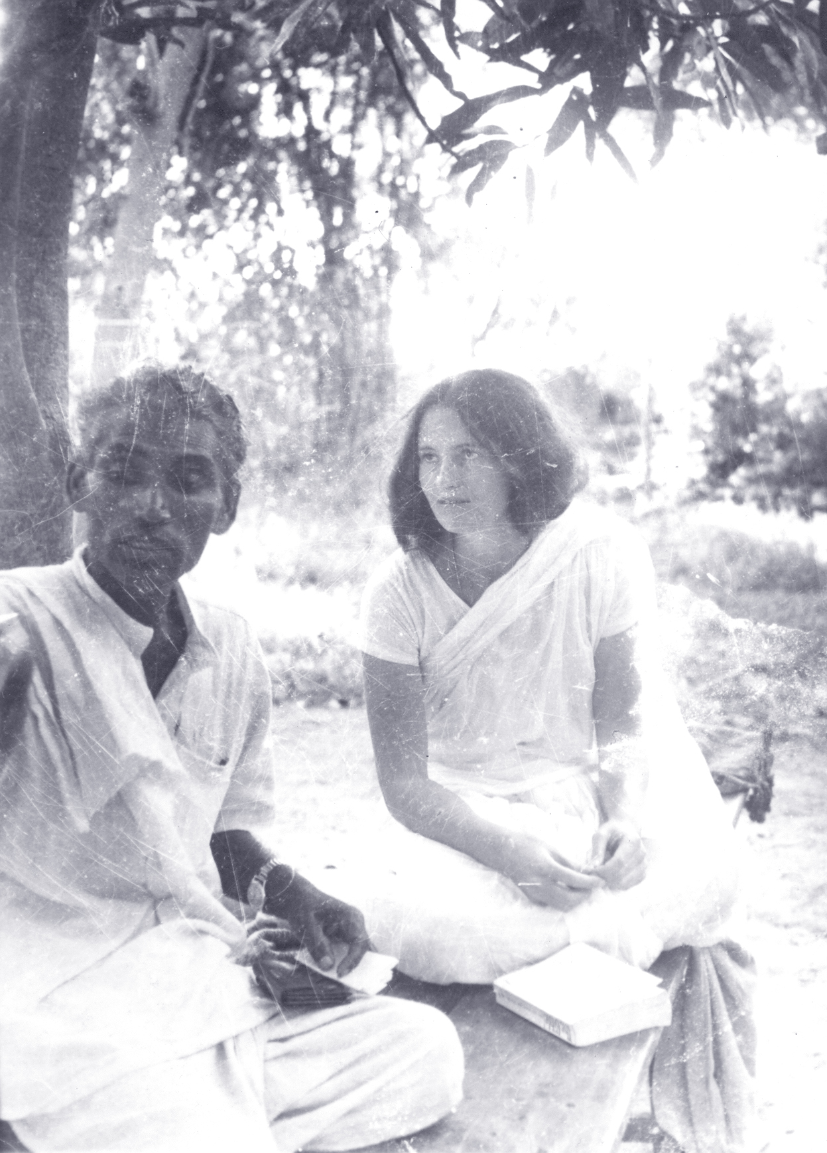
Manickam, a dedicated Sarvodaya worker, based at Thiruvarur Peace Centre
and Chris during fast at Keerungudi

Nagoramma, one of the women from Keerungudi, came and sat beside me. She watched me intently. Then she asked something in Tamil. Krishnammal translated: “You have everything in your land, why do you come here to starve with us, who have nothing? Nobody, no government official, no doctor, no politician, no one outside our caste, has ever crossed that coconut-tree bridge until now. Why are you here?” Krishnammal translated my reply: “ It’s true, in my country most people have far more than you, but how can I enjoy it when I know you are hungry and suffering injustice!” Nagoramma was silent, still staring at me, but something had changed: a bond was born. Over the years, she became like a mother to me, and when the people of Keerungudi helped to build my own small hut, it was she who gave a piece of land opposite her own hut. Later she would tell me of her life, her early widowhood, with two small children and how she was beaten and abused by the mirasdar, and how she struggled to find work in a culture where single women were not easily employed. I once asked her how, in spite of all she had suffered, she was so often laughing and always thinking about others. “All I have lived and suffered is written here,” she said simply, as she held her brow above her eyes. “That is for God alone.”
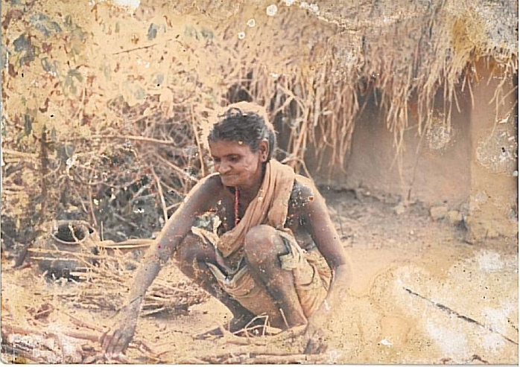
Nagoramma

The struggle for justice in Valivalam continued for many years. At one level the goal was to release the land, which the mirasdar had appropriated into the Valivalam temple trust, and distribute it to the landless tillers. At another level the goal was to encourage a different way of life based on the dignity of all. If each has a right to the land they till, a right to the fruits of their labour, to adequate homes, education, health, and self-determination, each also has responsibilities to respect and ensure the rights of others to these things.

My life in Keerungudi had begun. I had no idea how significant was the manner of my arrival to the way I was welcomed and seen. Even many years later, as I was taking my bath in the tank pond, beating my sari on the washing stone, a distant relative of someone married into the village was visiting. “Who is that white woman?” he asked as he passed. I was amazed at the reply, “Oh, that is our akka, she lives here with us. The Communists were always telling us to protest against the mirasdars, but if the police came they just ran away. But she came to jail with us.”

Part 2. Staying in Keerungudi

It is not easy to condense the richness of nearly six years. These are just a few glimpses of daily life in the village, including the experience of powerlessness and yet keeping hope in bleak times. The Sarvodaya movement introduced some changes. Accompanying Krishnammal Jagannathan when she came was always an adventure and inspiration.

Daily life in Keerungudi revolved around the seasons of transplanting and harvesting paddy. The times in between involved a lot of waiting, surviving, and foraging – tiny crabs from the pond and rats from the bunds were considered delicacies. I joined these seasonal changes as best I could. There was great joy in transplanting rice, sloshing about in the mud, moving with the rhythm of the women’s singing. I did not work day after day, nor quickly enough to earn my supper, though I shared enough to experience some of the less idyllic aspects of the work. Standing in infected mud and water for hours caused maddeningly itchy feet.

The quality of harvest varied from year to year. Scything, gathering, drying on the road and winnowing could make for a long, hot day. Taking paddy to the mechanical mill a few miles away was a recent innovation, easier than pounding it by hand, though the polished rice was less nutritious. Wages were paid in paddy. If it was a poor harvest, the people might be paid with mouldy and foul-smelling stock from a previous season.

Sarvodaya worked for changes in education, provision of safe water, and most fundamentally the control of the land. One priority for Keerungudi and other cheries in the area was the provision of Balwadi schools for the youngest children. In theory the hope was that older children, who had to care for their younger brothers and sisters while parents went to work in the fields, would thus be freed to go to school themselves. (Although legally they had the right to education, there was no tradition of schooling in the cheries. There was no money for a uniform or slate not to mention the prejudice and discrimination they would face).

Eight Balwadi schoolteachers were recruited by the Sarvodaya Mandal to work in various villages in the area around Kizhvelur. They held classes for the younger children during the day, and started night classes for the older ones who wanted to learn to read and write. There was a gathering for mothers too. Gnanam, who came to live in Keerungudi, was one such teacher. She taught me a lot, including where to find edible leaves, and skillfully cooked nutritious meals for me, especially when I was recovering from hepatitis. Forty years later we are still friends.

In Keerungudi water from the ditch or from the tank-pond was used for washing pots, clothes and buffaloes, as well as for our bathing, cooking and drinking. The Gandhi Peace Centre obtained funds to construct a small well, but mostly people preferred their traditional sources. Gnanam cooked a mid-day meal for the children at the Balwadi. Some mothers were sure their children were getting diarrhoea from the well, and insisted the ditch water was safer. There was of course no toilet, just an area on the edge of the cheri. Diarrhoea was chronic and the stars became very familiar with frequent exits into the night.

I had set up my mat-weaving loom, but goats often chewed my unfinished work if I was called away to accompany someone to the dispensary, to help out in the Balwadi or to visit a landlord with Krishnammal.

Even in the leanest times, people always greeted me when I passed their huts, with “Have you eaten?” They would share their khanji water or fermented rice from the night before, if they had any. What dignity, what forbearance and what hospitality! As ever it was most generous from those who had least.

I remember a young girl sitting forlornly beside her roofless home broken by the storm of a few days before. Gnanam, who went daily to collect the small children for the Balwadi, asked, “Why is your home like this?” The girl first looked ashamed and then smiled broadly as she replied, “Maybe to let the breeze through!”

Often in the hot season, when the ground could be scorching, people would look at my bare feet, and exclaim with horror and pity. I said “But none of you have chappals!” “But that is different, we were born to it, it is our destiny” they replied without any sense of self-pity.

One year there was a severe cyclone. I was in Chennai at the time, and could not return for several days as fallen trees blocked all the roads. Finally I was able to travel. In Keerungudi itself, thankfully, nobody had died or been seriously injured but they had not eaten for nearly three days. Almost all the huts had been destroyed, and their few possessions blown away by the swirling winds. The day I arrived a quota of rice had been distributed. That evening everyone gathered on a threshing ground, and made a fire to cook the rice in a borrowed pot. They could find only one plate. Because of the storm even banana leaves, often used for special meals, were unobtainable. It was one of the most memorable meals I have ever had, lasting nearly four hours. Children and the infirm were fed first. Without haste or greed or agitation, the plate was passed around from one to another. There were songs and stories and laughter, while we waited patiently and gratefully. What a contrast to Krishnammal’s description of being in prison in Thanjavur. There too there was only one unwashed plate. Women ate only after the men. The cells were so small and crowded, they had to take turns to sit down, and the toilet was a stinking hole in the same room. They were there not because of a natural calamity but because women, under cover of night, had dared to sing bhajans on roads designated for those of upper castes and claimed their right to land illegally enjoyed by the mirasdar.

Krishnammal, the wife of Jagannathanji, embodies the highest ideals of compassion and service, without a thought or care for herself or her comfort. She had one ear to the ground, attentive to people’s needs and rights, and the other ear always open to inner guidance from within to find a solution to the suffering she saw. She traveled constantly - to Chennai, Madurai, and all over Thanjavur District, to Delhi where she would not hesitate to appear before the highest authorities; and to Bihar at the height of the peaceful Total Revolution initiated by J.P. Narayan and the ensuing struggles during Indira Gandhi’s “Emergency” crackdown. But whenever she came to Kizhvelur, she would collect me from Keerungudi. Sometimes she perched on the back of my bike, sometimes we walked for miles, to meet and motivate people of all kinds who might help in her mission to bring justice and dignity to the landless poor. We met with advocates who might help with a land or property issue, or with landowners who might be persuaded to donate something for a particular need. We met politicians, and we met the landless people in tea shacks before they went off to work in the fields at dawn…. We slept wherever we ended the day, bathed and washed our clothes when we found a stream or pond, ate when we were offered food.

One day, we had to wait to meet some official in a small town. It was mid-day. We had not eaten and were exhausted in the hot sun. We sat in the dusty gutter, outside a big house that had steps leading to its gate. We were busy planning our next strategy when the lady of the house came out waving a stick and rudely shooed us away as if we were beggars and a source of pollution. I remember feeling so happy that my appearance blended in sufficiently well to be identified with the poorest and most despised!

Thanks to Jagannathan’s earlier fast, the Chief Minister of Tamilnadu passed an order legitimizing the right of people to own at least the huts they occupied. The day before they were to be registered, people from Vallam, one of the smallest and poorest cheries of Valivalam called us. Men sent by the mirasdar had destroyed their huts in the night, attempting to erase all evidence of their existence. In a poem at the time I wrote:

Just a few huts cast out
even from other outcastes
yet strange threat
to our lord of the land
who must prove his right
(but only in the cowardly night)
to this poor, unprotected plot
of struggling existence

His men descend, destroy,
tear off leafed roofs, drunkenly hack
the air, waving their sticks, kick
in the crumbling walls
while women scream

Krishnammal and I set off at once and found the women in a state of shock. Their men had run away in fear. One mother lay on the ground sheltering her tiny child from the scorching glare with her body and her torn sari. As they had nowhere to go, they were afraid that these men hired by the mirasdar, would return in the night and abuse them. They told us what had happened the night before.
Lifting a rag, a young girl pointed
to one mud pot and a grinding stone.
“That is one family,” she said.

In the night a blundering buffalo
broke the pot

We sat, we listened, and we waited all day without food or water or shelter, sharing in their shame and powerlessness. There was yet a moment of laughter as a group of us sat one behind the other, delousing the hair of the one in front, chatting to forget the dread of the night to come. Krishnammal and I stayed with them under the stars, hoping our presence would afford some protection or security. The men did indeed return, drinking and shouting, brandishing their weapons. Until dawn they stayed behind some bushes making obscene and abusive taunts, as we huddled together. Thankfully they did not come closer. Early next day, Krishnammal and I prayed together on a nearby threshing ground. She often spoke of her devotion to the Tamil saint, Sri Ramalinga Swami. Almost constantly she sang and prayed his Divine Song of Grace: Arut Perum Jyoti, Thani Perum Karunai… Supreme Light, boundless and benevolent, Infinite Grace poured out in absolute compassion…By the time we finished praying she had a plan. We went first to a sympathetic mirasdar nearby to beg for a bit of wasteland and some bamboos. Then we went to the other cheries to ask for labour to make mud walls, and for coconut fronds to be given and plaited for the roofs. Amazing response! Krishnammal had to leave that evening, and though exhausted she was confident. The poem continued:
The week moves slowly…
we wait for the sanction of the government surveyor
for the passing of an inauspicious day
and then the marriage of a distant cousin
and now a death in a nearby cheri….

But in the end the huts were built, and people dared to hope again.

Soon however there was more provocation from the mirasdar. Once again his men, who had been plied with drink, were sent to harvest a paddy field close to our cheri of Keerungudi. We women quickly decided to prevent the harvesting by putting our arms wherever the men were about to scythe with their sickles. At first it seemed to be effective: the men did not hurt us and could not harvest. But I did not understand the insult and disgrace of the verbal abuse, which began to be directed towards the women. It was too much for the men of Keerungudi watching from the roadside. Suddenly large stones were thrown into the field, and in no time there was a serious fight between the two sides on the road, where unfortunately there were several piles of stones ready for a major repair work. I stood between the mirasdar’s men and the people of Keerungudi, begging them both to stop (and the latter begging me to get out of the way!). I will always be grateful for the gift of knowing I was where I was meant to be and the grace of being totally without fear. Eventually it ended, though some of us, including several children, were wounded. Nevertheless there was a small sign of change. News spread, but the police took no reprisals against us and the event was even reported with understanding by a journalist who interviewed me. But the struggle with the mirasdar was not over, and we failed to change his heart. Only after years of legal wrangling, the first land from the Temple Trust was released from the mirasdar’s control, and 100 acres of fertile wetland was distributed to fifty families, including many from Keerungudi.

I wrote another long poem called “A cycle of waiting” in the worst year of famine during those six years. Here are a few extracts:

With the fever of the harvest long since subsided
the seed is sealed
A stillness over the land
still enough to see the heat rising
to hear insects in the bleached stalks
to feel the scorched earth crack

A deep waiting of the land
for water, of eyes for the fresh green of young rice…
a waiting in fear and hope for land itself
waiting for humanity and decency
and the life of our children.
It is waiting in anger and truth
for the right to abandon the waiting

Across the waiting, learning to listen
to the laughter of children
searching in the bunds
for tasty rats to roast

… harder in the night to hear
the incessant drone of the mirasdar’s oil engine
pumping away the last of our drinking water
to raise an early crop for profit
and the sound of drums announcing at dawn
another death…
Now we are eating away the seeds
that were sealed for next year’s sowing,
the last brass pot and nose-ring
pawned or sold long ago.
The faint hope of tomorrow
disappears into our blood
as debts and despair mingle with our sometimes food

Yet the faint hope of today still rises
as the waiting silence of the earth continues to call:
‘Reap, reap the fruits of steadfast love.’

Tiny clay lamps
Gandhi had renamed those formerly described as “untouchable,” as “Harijans” (“children of God) but the self-designated preferred term Dalit, roughly means “of the land. who are oppressed.”
slum settlement
Indigenous tribal people
dan, gift, including the gift or sharing of power, land, labour, wealth, tools, even one’s whole life, for the well-being and uplift of all
ahimsa, the refusal to harm, or to co-operate with evil even at the cost of personal suffering, with the intention of awakening the deepest and highest in our humanity.
A cheri is a satellite settlement where Dalits lived around a main village. Often they were situated far from the road, on the poorest land, swampy or uncultivable. In the 1970s Dalit people were not allowed access to water from the major reservoirs and tanks, to schools or temple, or even to many streets in the main village.
Mirasdar, local word for landowner
Benami – land or property owned or held by one party, but registered in the name of another, or a Trust, (educational, health centre or temple), enabling the person who really controls it to circumvent laws or evade taxes for example, for their own benefit.
Bund – a narrow bank separating small paddy fields
elder sister
Balwadi a kindergarten or nursery for young children
Khanji, the water in which rice has been cooked
chappals Indian sandals
bhajans, devotional songs
Krishnammal and Jagannathan have received numerous awards for their life-long service to the poorest and most oppressed people in Tamilnadu. In 2008 they jointly received the Right Livelihood Award. Their years during the Freedom struggle with Gandhi and later with Vinoba were pivotal in their formation, but they have each developed their own unique application of the values of Sarvodaya. A fuller account of their extraordinary lives is in The Color of Freedom by Laura Coppo. 2005
mirasdar, local word for landowner
Hosea, 10:12

